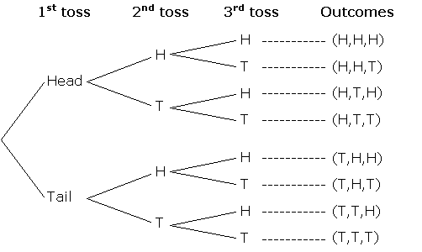1.

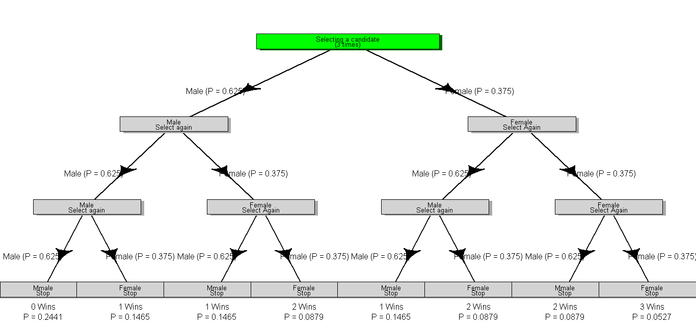2.

> n <- 3

> males <- 25

> females <- 15

> prob <- females/(males+females)

> mean <- n\*prob

> mean

[1] 1.125

> var <- n\*prob\*(1-prob)

> var

[1] 0.703125

3.

> p1 <- punif(8,a,b)

> p2 <- punif(6,a,b)

> prob <- p1-p2

> rand <- runif(15,a,b)

> rand

[1] 9.942252 6.240213 7.049267 9.440394 8.652758 6.608389 6.243446 5.544504

[9] 9.385444 5.275819 7.175759 6.901909 9.292727 5.879690 5.896615

4.

p = 1/6

n = 5

P(x>=3) = P(3)+P(4)+P(5)

[0.0356]

5.

P = 1/3

n = 4

x = 4

P(X = 4)

[0.01234]

6. The expected number of successes in each case is identical(24/36=4/6), but the probabilities are different. Rolling four dice is better than even, and rolling 24 is worse.

> 1 <- pbinom(0,4,1/6)

[1] 0.5177

> 1 <- pbinom(0,24,1/36)

[1] 0.4914

7.

> mu <- 350

> sigma <- 75

> a <- 450

> za <- (a-mu)/sigma

> proba <- 1-pnorm(a,mu,sigma)

> proba

[1] 0.09121122

> prob2 <- 1-pnorm(za,0,1)

> prob2

[1] 0.09121122

8.

> n <- 30

> mu <- 350

> sigma <- 75

> b <- 470

> pb <- 1-pnorm(b,mu,sigma)

> pb

[1] 0.05479929

> zb <- (b-mu)/sigma

> pzb <- 1-pnorm(zb,0,1)

> pzb

[1] 0.05479929

9.

> f <- 1-pnorm(22,20,6,5.5)

> f

[1] 0.3995371

Almost 40% passed the exam.

> x <- 1000000\*diff(pnorm(c(22,23),mean-20.6,sd=5.5))

> x

[1] 68251

10.

> z = dnorm(24.9,1.05^2)

> y <- pnorm(z<26)

> y

[1] 0.8413447

> norm <- qnorm(0.95, mean=24.9, sd=1.05)

> norm

[1] 26.627111

11.

> mu <-12

> sigma <- sqrt(0.5)

> a <- 10.7

> za <- (a-mu)/sigma

>proba <- pnorm(a,mu,sigma)

> proba

[1] 0.03299603

> proba2 <- pnorm(za,0,1)

> proba2

[1] 0.03299603

12.

Functions<-function(n,a,b)

{

Rand<-runif(n,a,b)

Rand2<-1-rand

Out<-rand\*rand2

}

> first<-Functions(20,0,1)

> yr10000<-Functions(10000,0,1)

> yr10000

[1] 0.1658917